Lab 1: Packet Analysis with Wireshark

"I used my own network capture for this analysis"
Question 1: Protocol Analysis
The capture contains a variety of protocols as shown in the filtered Wireshark list below
- TCP: Present.
- QUIC: Present.
- HTTP: Present.
- DNS: Present (confirmed by UDP traffic over port 53). DNS primarily uses UDP because it is a connectionless protocol that provides faster response times and lower overhead for small, simple queries.
- UDP: Present.
- TLSv1.2: Present (usually found within HTTPS traffic on port 443).

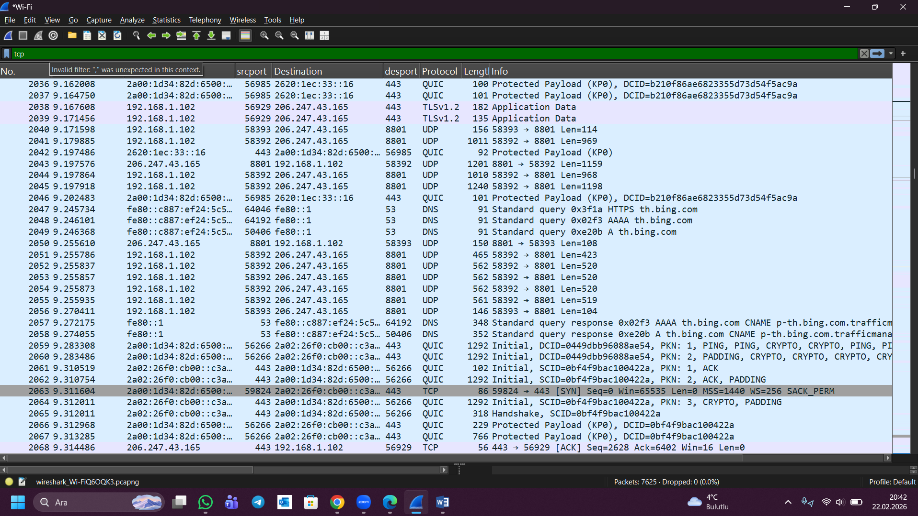

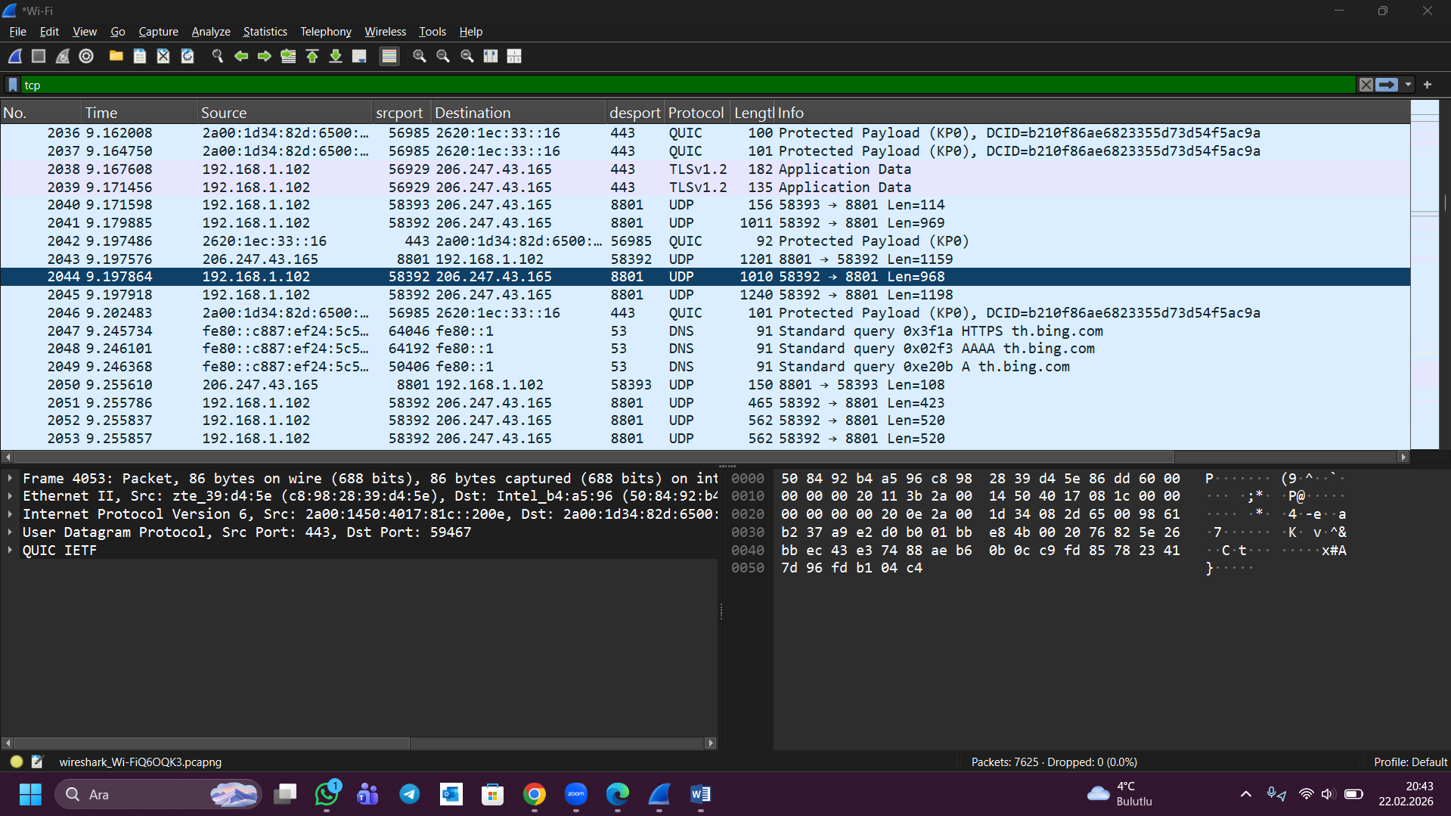

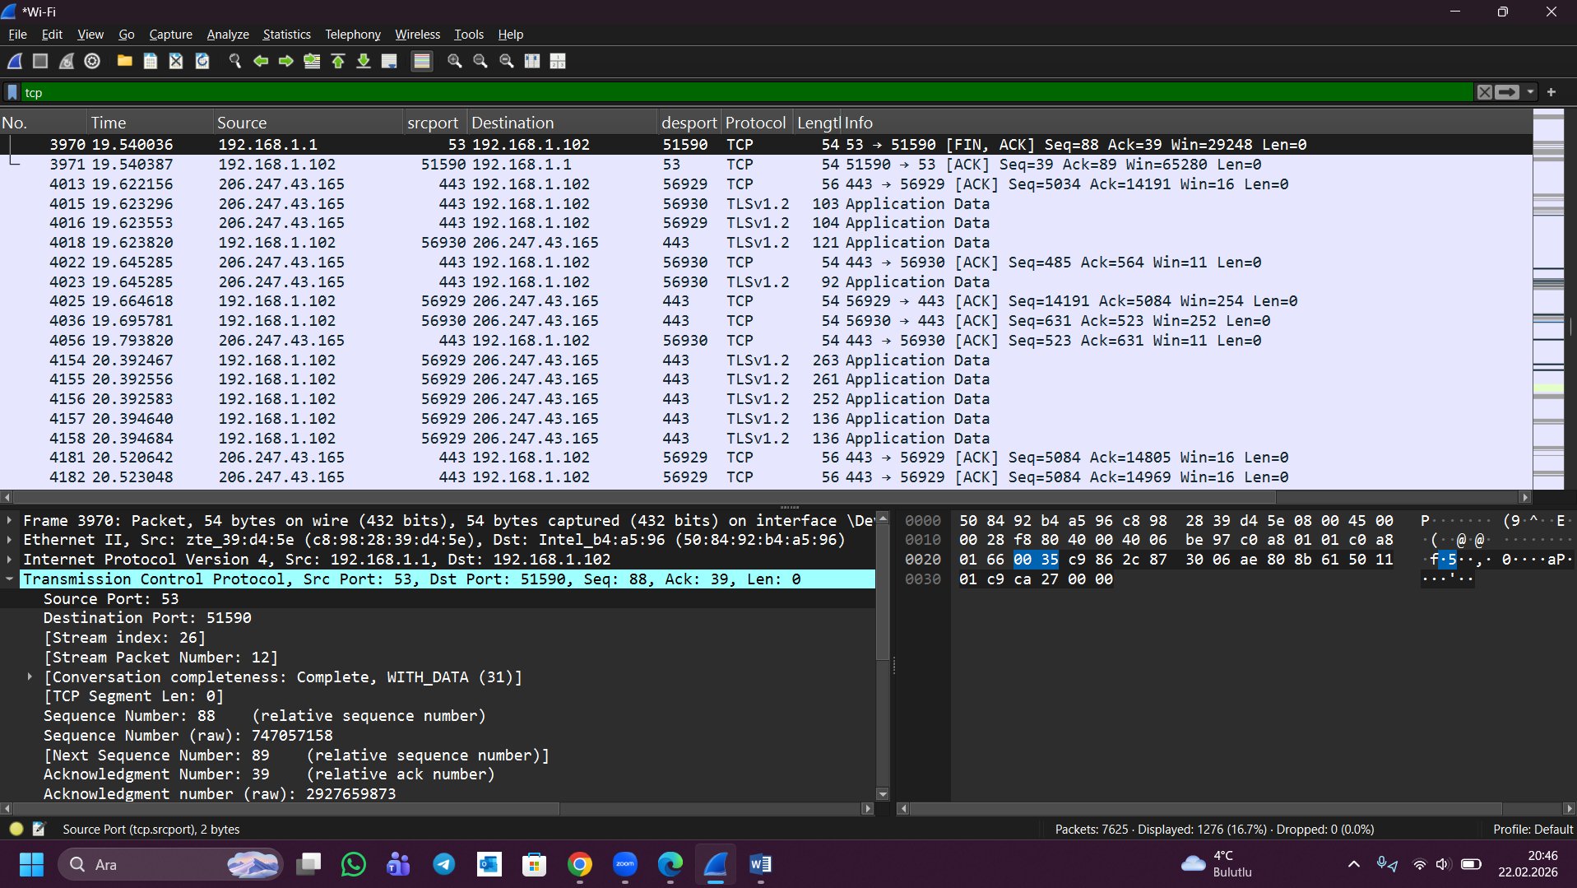

Question 2:
hakanvardar.me IP Adresi (Destination): 187.77.70.197
My computer IP Adresi (Source): 192.168.1.102
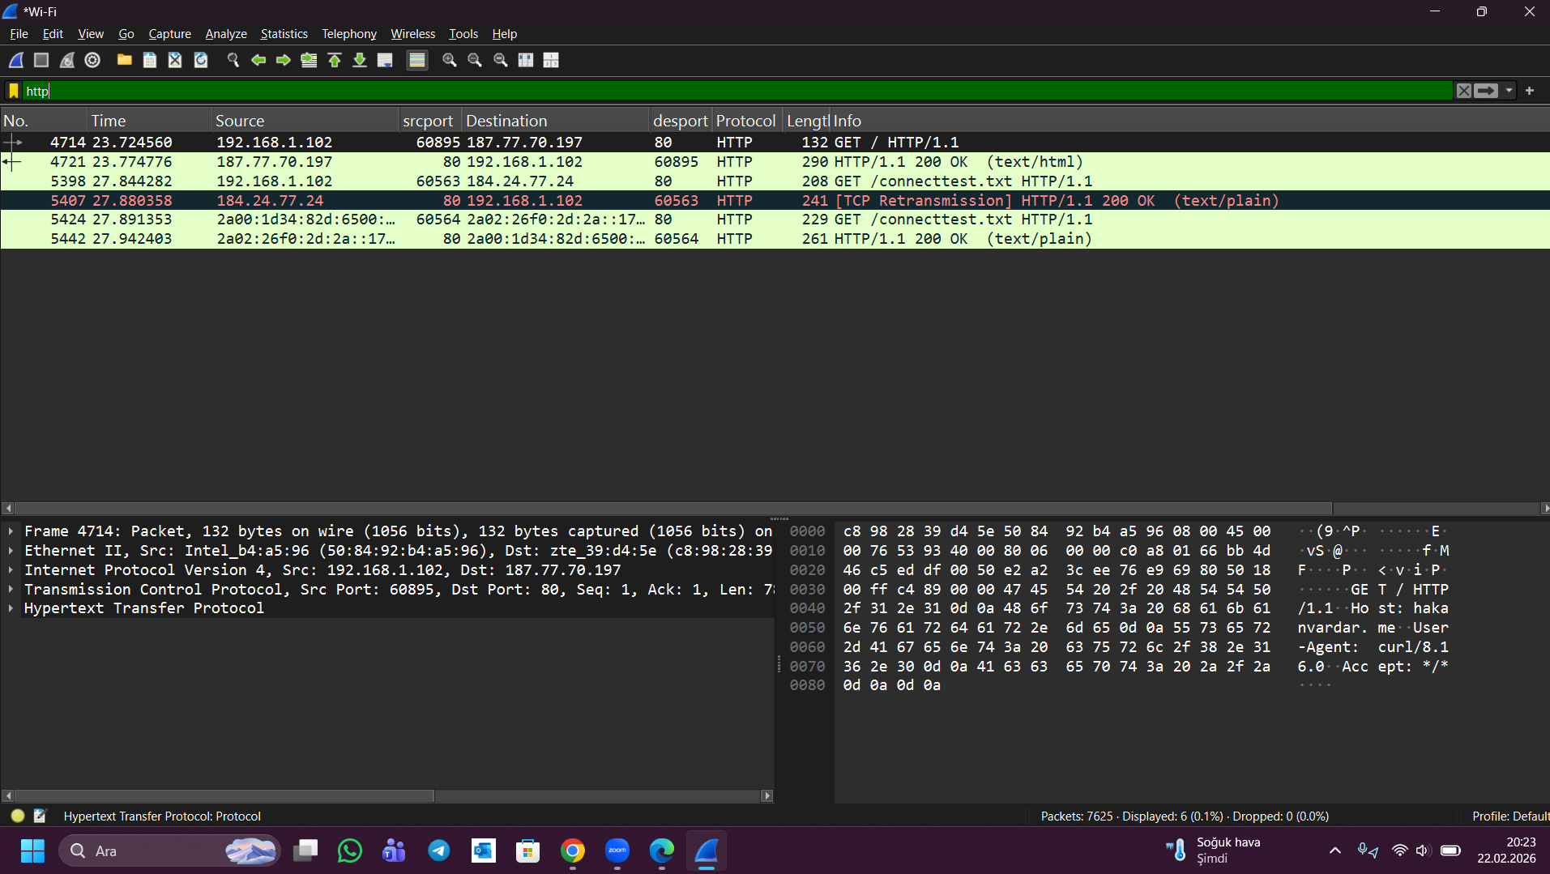

Question 3:
Question 3: Time Analysis
The time elapsed between sending the HTTP GET request and receiving the response is calculated as follows:
- HTTP GET Request (No. 4714) Timestamp: 23.724560 seconds
- HTTP Response (No. 4721) Timestamp: 23.774776 seconds
Calculation:
23.774776−23.724560=0.05021623.774776 - 23.724560 = 0.05021623.774776−23.724560=0.050216 seconds
Answer: It took 0.050216 seconds (~0.050 s) ) to receive the HTTP response.
The elapsed time of approximately 0.050 seconds (50 ms) indicates a very fast response. In network terms, a Round Trip Time (RTT) under 100ms is generally considered excellent for web browsing, suggesting that there is minimal network congestion and the server processed the HTTP request efficiently.

Question 4:
When the selected HTTP GET request (No. 4714) is examined, the TCP port numbers are as follows:
- Source Port: 60895
- Destination Port: 80

Explanations:
- Client Port: The source port 60895 corresponds to the client (my computer). Clients typically use high-numbered, temporary (ephemeral) ports assigned by the operating system.
- Server Port: The destination port 80 corresponds to the server (hakanvardar.me). Port 80 is globally reserved as the standard port for HTTP traffic.

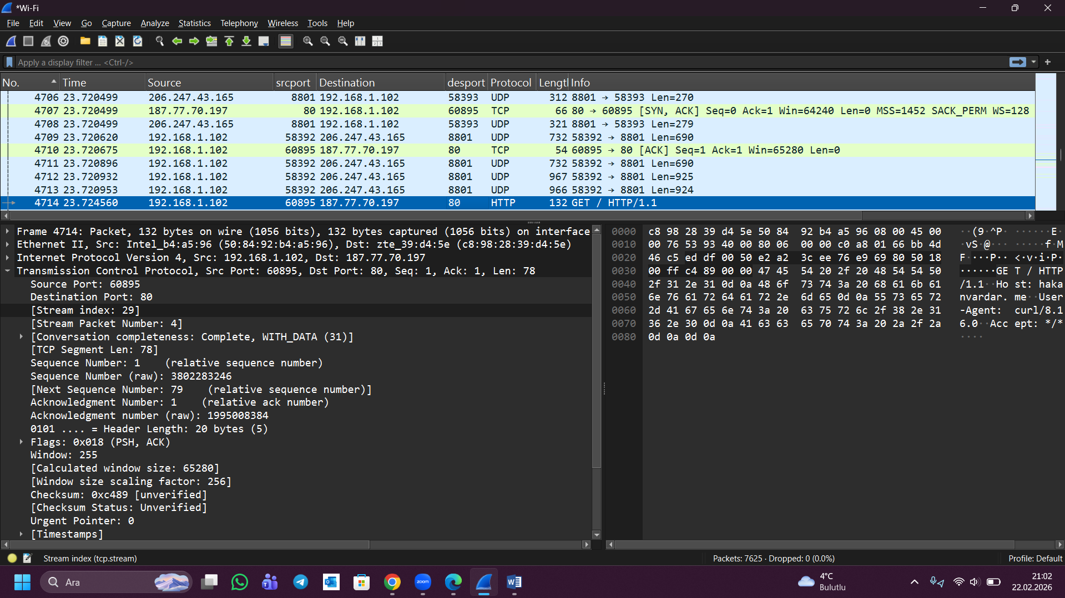

Question 5:
HTTP Response Status Code: 200
Meaning: The “200 OK” status code indicates that the HTTP request sent by the client was successfully received, understood, and accepted by the server. In this case, the server successfully returned the content from http://hakanvardar.me within the packet.
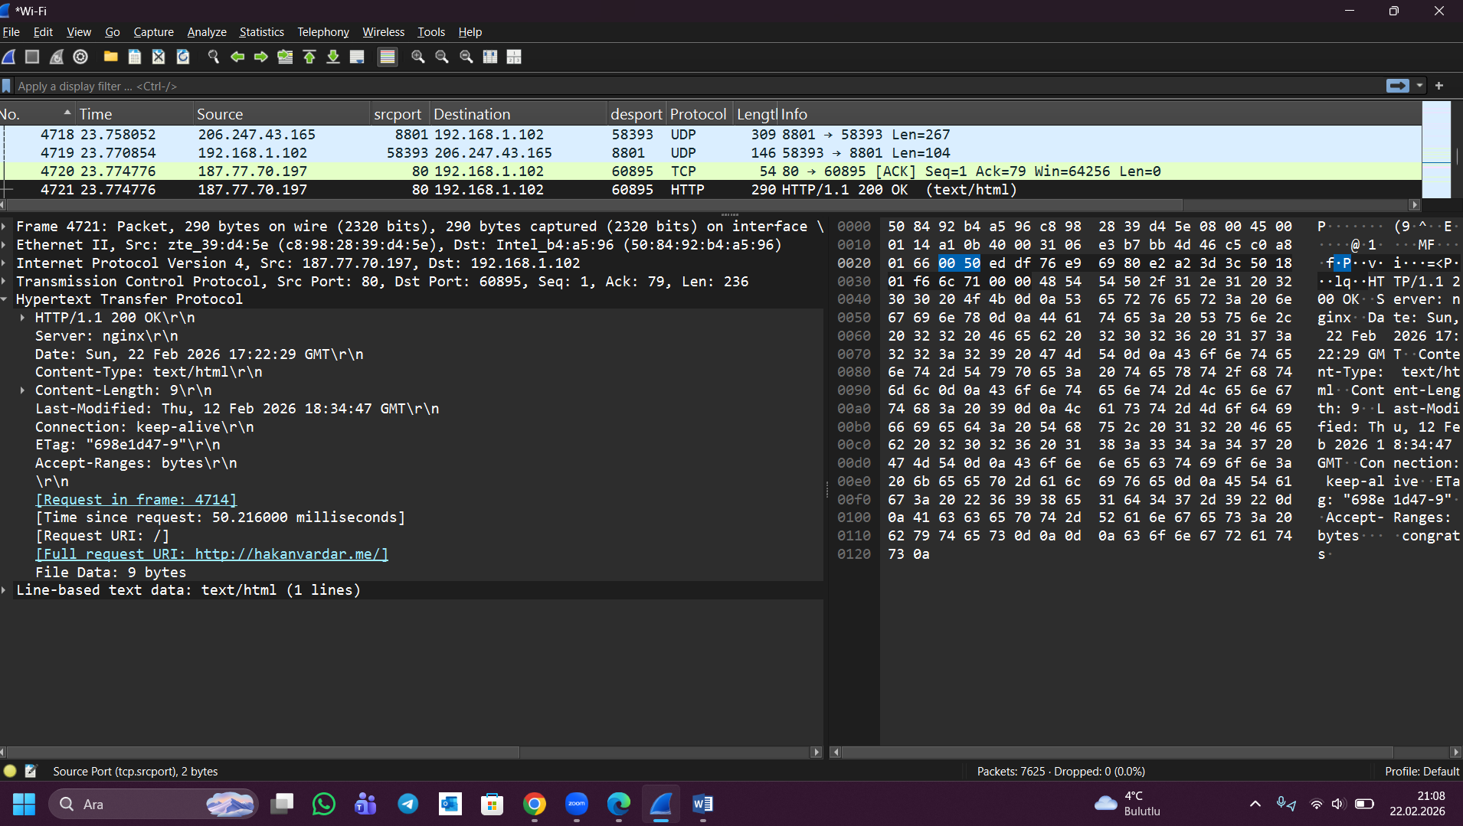
Question 6:The byte value was not calculated manually. Wireshark automatically determines the total packet size.
The size can be seen in two places:
- In the Packet List pane, the Length column for Packet No. 4721 shows 290 bytes.
- In the Packet Details pane, under the Frame section, it states:
“Frame 4721: Packet, 290 bytes on wire.”
- Therefore, the HTTP response packet size is 290 bytes, as directly displayed by Wireshark.
